**PART I - SPECIFIC ASSIGNMENTS**

1. Calculate the mean and median number of points scored. (In other words, each row is the amount of points a player scored during a particular season. Calculate the median of these values. The result of this is that we have the median number of points players score each season.)

The mean number of points scored: 492.1306892341375

The median number of points scored: 492.1306892341375

1. Determine the highest number of points recorded in a single season. Identify who scored those points and the year they did so.

The highest number of points: 4029

The year of highest number of points:

points year firstName middleName lastName nameSuffix

2078 4029 1961 Wilton Norman Chamberlain NaN

1. Produce a boxplot that shows the distribution of total points, total assists, and total rebounds (each of these three is a separate box plot, but they can be on the same scale and in the same graphic).

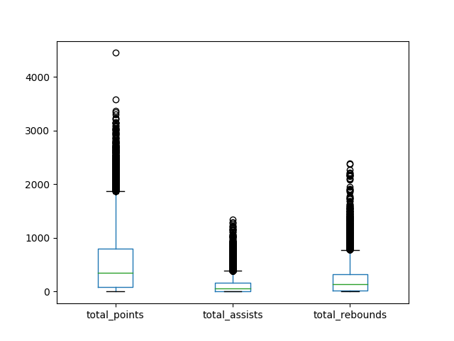

4. Produce a plot that shows how the number of points scored has changed over time by showing the median of points scored per year, over time. The x-axis is the year and the y-axis is the median number of points among all players for that year.

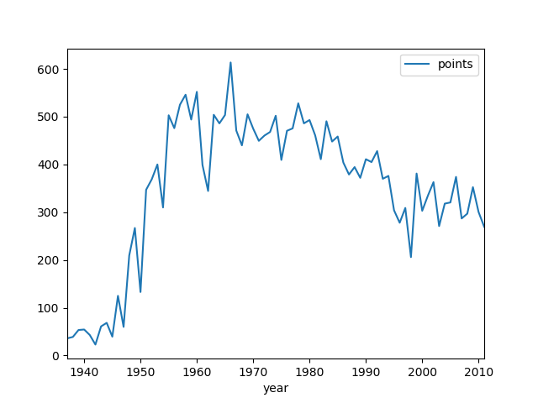

#### PART II - COME UP WITH SUPPORTING EVIDENCE

1. Some players score a lot of points because they attempt a lot of shots. Among players that have scored a lot of points, are there some that are much more efficient (points per attempt) than others?

Here is the list of top 10 players who are have higher points per attempt than the other players.

firstName middleName lastName PointsPerAttempt

Norm NaN Rosen 11.222222

Robert J. Skarda 10.000000

Harry NaN Johnson 7.666667

Harold NaN Lambert 7.666667

Paul Wally Napolitano 7.380952

Ralph English Bishop 7.333333

Garland M. Head 7.000000

Paul NaN Juntunen 6.342105

James NaN Goff 6.220779

Frank E. Shannon 6.200000

1. It seems like some players may excel in one statistical category, but produce very little in other areas. Are there any players that are exceptional across many categories?

firstName middleName lastName nameSuffix

Michael Jeffrey Jordan NaN

LeBron Raymone James NaN

Wilton Norman Chamberlain NaN

Kevin Wayne Durant NaN

Karl Anthony Malone NaN

Kareem NaN Abdul-Jabbar NaN

Oscar Palmer Robertson NaN

Robert E. Lee Pettit Jr.

Julius Winfield Erving II

Kobe Bean Bryant NaN

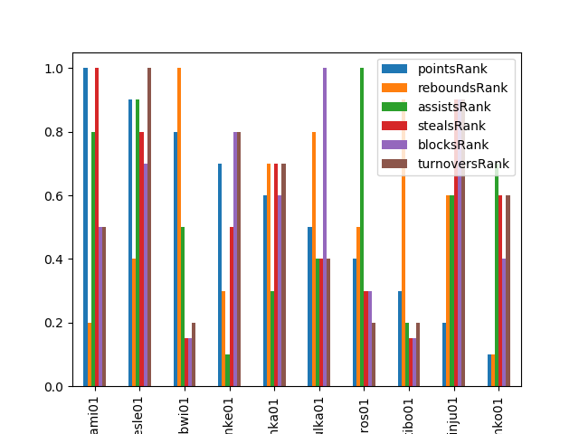

1. Much has been said about the rise of the three-point shot in recent years. It seems that players are shooting and making more three-point shots than ever. Recognizing that this dataset doesn't contain the very most recent data, do you see a trend of more three-point shots either across the league or among certain groups of players? Is there a point at which popularity increased dramatically?

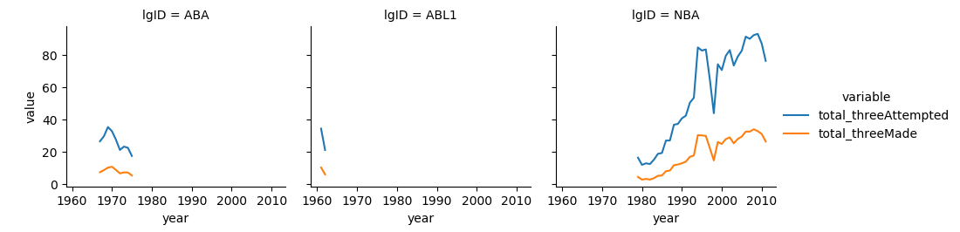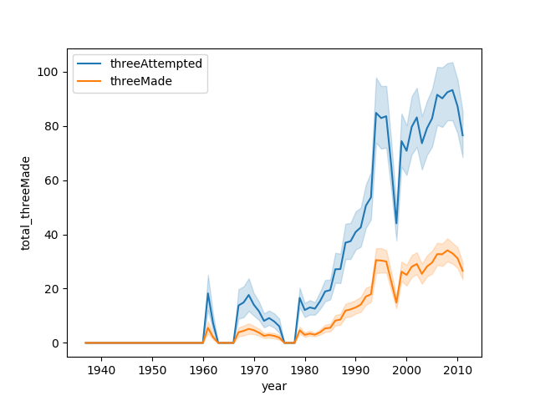

#### PART III - SHOW CREATIVITY

1. Many sports analysts argue about which player is the GOAT (the Greatest Of All Time). Based on this data, who would you say is the GOAT? Provide evidence to back up your decision.

I generated GOAT Score which calculates each rank of points, rebounds, assists, steals, blocks, and turnovers for players on percentage format and add them up by allotting a proportion of 50 % to points, and giving 10 % to rest of stats. And here is the list of top 10 players who can be referred as GOAT.

firstName middleName lastName nameSuffix GOAT_score

Julius Winfield Erving II 0.994758

LeBron Raymone James NaN 0.993310

Larry Joe Bird NaN 0.992046

Karl Anthony Malone NaN 0.990985

Michael Jeffrey Jordan NaN 0.989435

Kevin Maurice Garnett NaN 0.987722

Charles Wade Barkley NaN 0.986896

Hakeem Abdul Olajuwon NaN 0.985458

Kevin Wayne Durant NaN 0.985285

Dwyane Tyrone Wade NaN 0.984010

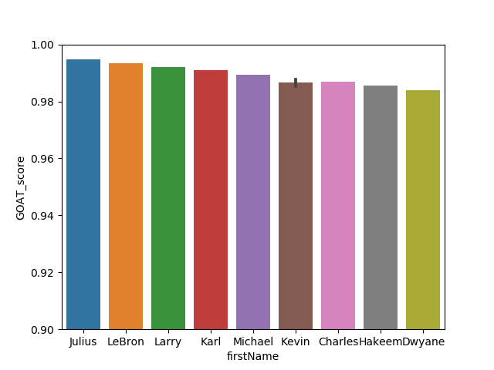

1. The biographical data in this dataset contains information about home towns, home states, and home countries for these players. Can you find anything interesting about players who came from a similar location?

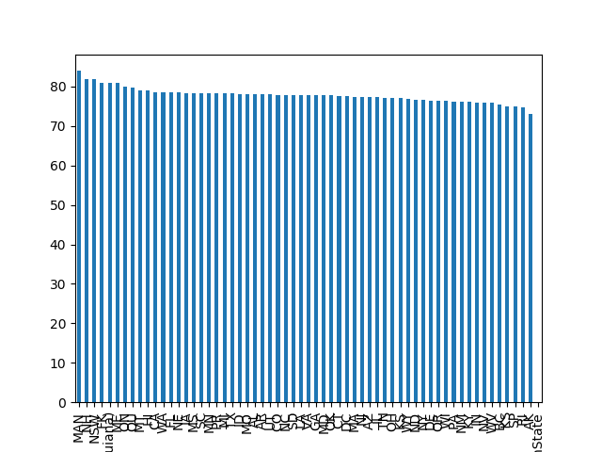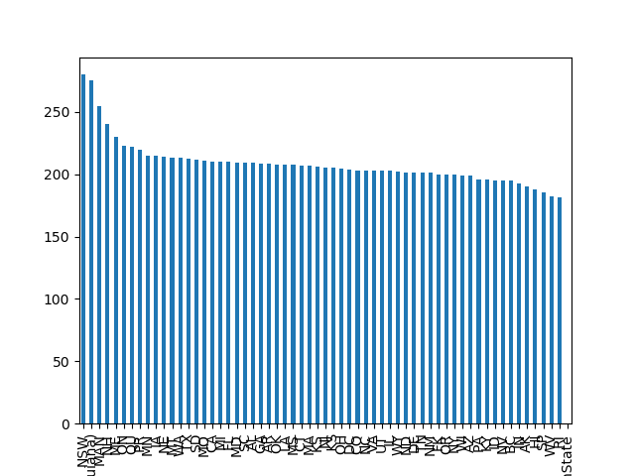

These are bar charts of mean height and weight of players who are from same state.

As you can see, MAN(Maine), NSW(New South Wales), NH(New Hampshire) states shows the high rate of weight and height compared to other states. Here is a closer view of bar charts with top 10 states.

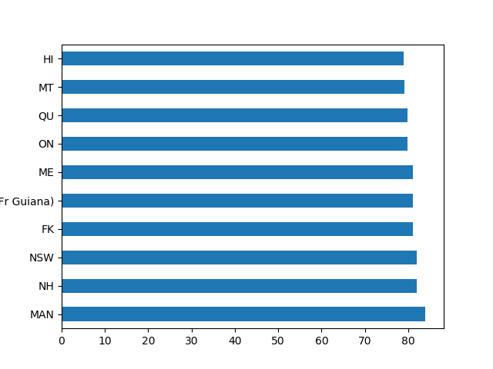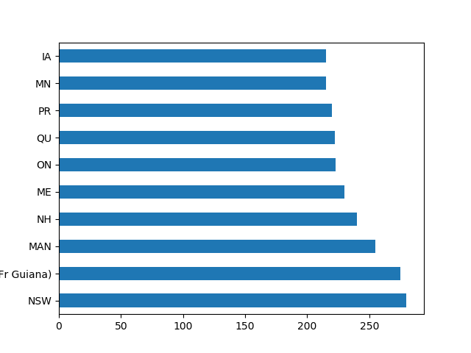

1. Find something else in this dataset that you consider interesting. Produce a graph to communicate your insight.

The correlation between weight and height per position

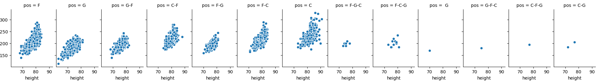

How much height have been changed over years per position

